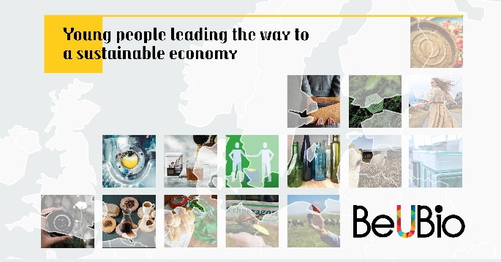
Young people driving the sustainable economy
Active and environmentally aware younger generations, including Generation Z and Millennials, are a major driving force behind climate change and sustainable development movements. By combining utopian ideals with entrepreneurial spirit, young people are developing new and innovative ideas and solutions to environmental challenges. Nordregio (Nordic Research Institute) together with the partners from the Baltic Sea Region (BSR), have created an inspiring brochure to show how the youths’ efforts are currently helping to make sustainability an important political issue and topic of everyday conversation. The following inspirational stories of young leaders from BSR, who have created products, services, initiatives, movements and are sustainable economy enthusiasts, showcase creative ways to begin the journey towards a sustainable economy.
The Estonian blogger Liisa Aavik has challenged herself by finding sustainable solutions to tackle resource waste. Her mission is to share some tips and tricks, with other like-minded explorers, for how to clean clothes and home, enjoy a drink using a straw and wrap the leftover food without generating additional waste or harm to the environment. Liisa bases her suggestions on her personal experience in searching for the waste-free goods from the local producers. “The intention is not to manipulate people but to help them understand how they can use this to their own advantage,” she emphasizes.
Meanwhile in Copenhagen, Juan Medina together with two friends from his home-town in Colombia established Kaffe Bueno, to reuse grounded coffee waste and turns it into the cosmetics, nutraceuticals and functional foods. From his background in Colombia, Juan has been familiar with the coffee culture and its secret health-enhancing compounds since childhood. With their company the team is exploiting the untapped potential of the coffee beans to minimise waste and generate value.
The Sweden-based team – Fredrik, Leo and Angelo – recalls their “final pitch”, “presenting the final pitch alongside Barack Obama and Greta Thunberg, Fredrik made our mission statement clear: get this seaweed out to as many cows as possible, as fast as possible”. The team is currently on a mission to cut 4% of the global greenhouse gas emissions produced by the so-called “Republic of Cattle”, through feeding cows with special red seaweed. The Sweden-based company, Volta Greentech, is taking giant steps towards reducing the environmental impact of the animal industry by enabling the production of methane-reduced meat and dairy products.

With the same objective – cutting greenhouse gas emissions –, Sami Holmström in Finland is creating proteins that require minimum water and land resources while leaving animals to live. Sami recalls that this form of protein production “was initially studied by NASA in the 1960’s but it is only now that the increased generation and affordability of renewable energy has made this possible”. He and Solar Foods expect that lab produced Solein® could be done in the Sahara Desert, the Arctic, or even the outer space, completely altering the geography of food production.

In north Germany, Nadine Sydow is helping preserve biodiversity by announcing peace between gardeners and snails and slugs which climb into slot gardens. Her invention “Schnexagon” is a natural combination of natural oils and surfactants that prevents slugs from sticking onto surfaces and thus preventing them from entering garden uninvited without the need of using pesticides.
Furthermore, unearthing the rural traditions of Vidzeme region in Latvia, Māra is producing teas from hand-picked wild herbs, while also creating opportunities in local communities. Her entrepreneurial spirit and love for her region has birthed PLŪKT teas which provides opportunities to local farmers and women and boost the local identity.
And more...
The BeUBio interactive platform was designed to collect stories of young people whose business ideas, jobs and other activities lead the way towards a different and more sustainable economic path. With a variety of different examples, young people from across the BSR, inspire new ways of making business while having a positive impact to the environment and society. The overall aim is to build a community of like-minded people, by sharing our stories and inspiring each other to be courageous and to develop ourselves in areas geared towards a sustainable economy. By seeking niche solutions, creating unique products and innovative services from renewable natural resources and related areas, we open the door to economic growth while adding value from currently underutilised natural resources. We are increasingly focusing on inspiring and informing entrepreneurs, society, youth, and owners of bio-resources about the untapped potentials of natural resources.
About the project
The BeUBio collaboration emerged from the ‘Baltic Leadership Programme on Youth and Bioeconomy’ which gathered about 30 young committed people across the Baltic Sea Region with an interest to push forward a sustainable bioeconomy. The BeUBio project received seed funding from the Swedish Institute to continue the cooperation and expand the network.
More information: Alberto Giacometti, Research Fellow at Nordregio, alberto.giacometti@nordregio.org
Prepared by: Marta Riekstiņa, Public Relations Specialist in Vidzeme Planning Region, marta.riekstina@vidzeme.lv

